Thai Khong
06/06/2026

Application and Network Log Evaluation Part 1

A1) Static Code Analysis is checking the code for errors, weaknesses, potential vulnerabilities, and organizations code rules (naming convention, indentation, and coding styles). Its role is to not help developers understand the code patterns but also see where there might be security issues. For example, developers can analyze input text boxes and make sure the input that users can input is limited and protected to prevent security vulnerabilities. Its role is more of a scan through the code while it’s static just to see the problems that present itself and fixing those problems first.
A2)
- Static code analysis can detect whether developers are following naming rules/conventions that the business agreed to follow.
- Static code analysis also gives developers the overall flow of the code and can break down parts of the code where there is a potential weakness, for example, at intersections where components interact with each other.
- Static code analysis has a scan which can see whether lines of code have security issues.
- Static code analysis also checks the code where the user inputs information and makes sure the input data has its proper constraint to mitigate hackers.
- Static code analysis can also make sure whether there is error handling, and log data where the code fails to run. This makes it easier to pinpoint bugs.
A3)
- There is a hard coded secret key string in the code which can pose a security risk because anyone who has the source code will be able to view the hard coded secret key posing a security threat.
- There is a hard coded password string coded as well. Anyone who has access to the source code will be able to view it since there’s no hashing, it’s in plain text, and it can be accessed by anyone with the source code posing a security threat.
- There is a missing input validation on line 112-115. This can pose a security threat because malicious hackers can input text that will lead to sql injection compromising the code. It’s important to always have constraints on what the users can input to improve security measures.
- There is a negative value exploitation in the code on line 120. This effects reliability since users can get refunds by entering on negative days and get refunds repeatedly. The outcome is a compromise in reliability in the business and can cause business money.
- Another issue concerning security is there’s no limit to how many times an attacker can attempt to log in which opens the door to brute force. This makes it easier for attackers to hack the business because they can just keep guessing password until it works ultimately posing a security issue.
B)
B4)
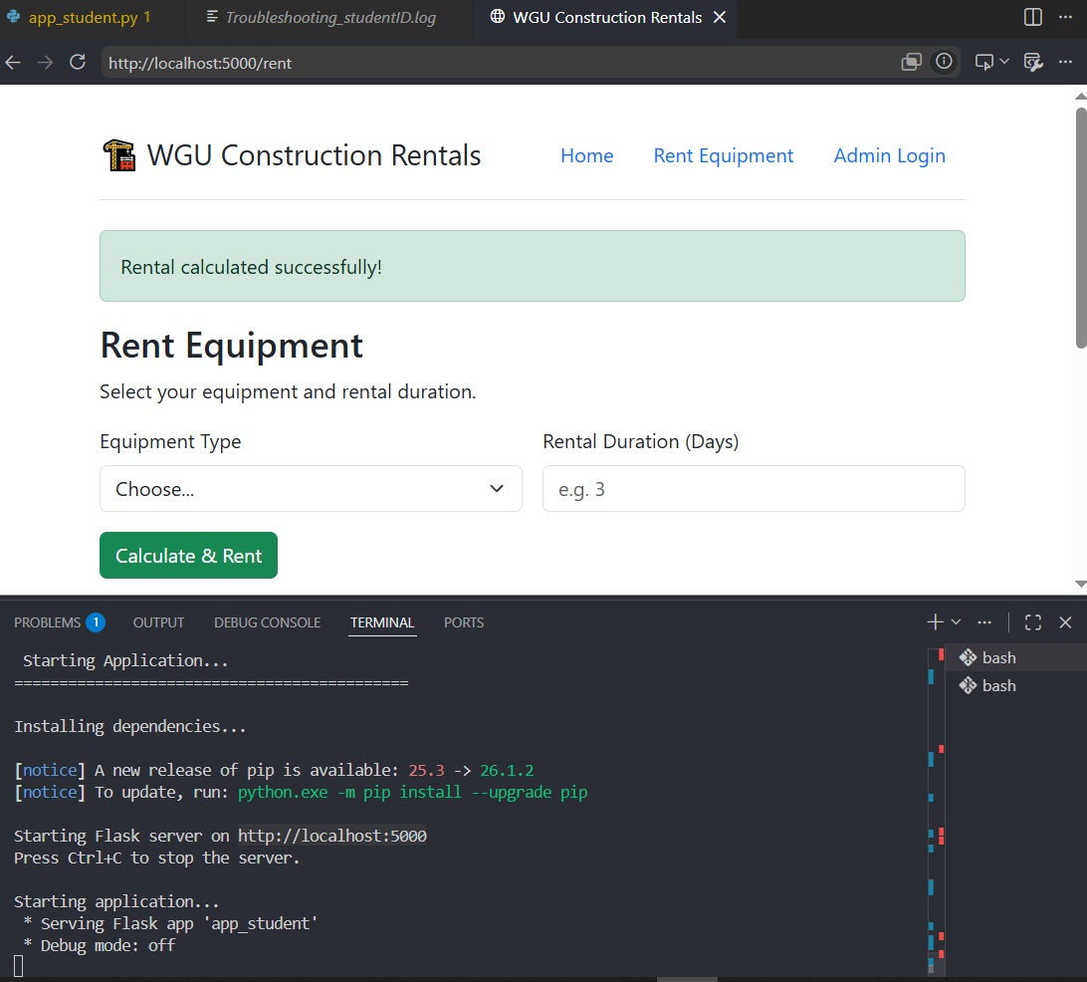
B5)
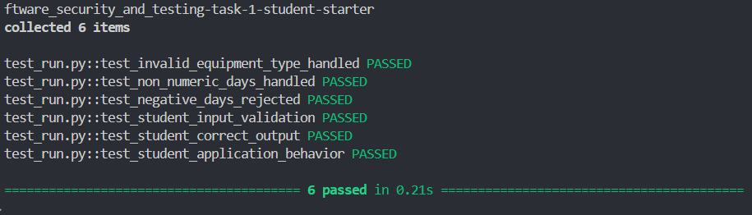

C)
1a) Log entries can reveal system issues by pinpointing where that issue occurred after a specific incident. After pinpointing those issues developers can observe their code and fix what went wrong. Furthermore, logging issues can provide developers with deeper insights into who is accessing what information and how many times they are attempting to access that information which leaves a trail and helps businesses identify whether they should be concerned about a certain action on the users end or not.
1b) There is log that identifies when users connect to the application by checking ip address. If the ip address does not start with 192.168. or 10., then the ip address would automatically be flagged as suspicious. This is useful in defensive coding by checking what ip address gets through to the application and if it’s a suspicious one, then it would notify the business in the log page which is important for business integrity and security. Another example would be the log that gives the total price paid when entering an item and a day. This helps developers identify the issues regarding what happens when users enter a negative day. This becomes a bug that affects the prices for items when renting. By being able to identify this problem developers can I add constraint/asserts that would handle negative days and output to user that having a negative day is an invalid input.
2a) One of the techniques that were used in the python script is logging. By logging events that occur after certain interaction with users, it leaves a trail for developers to find out what went wrong if certain expected results were not met. This saves time for developers by giving developers a general idea of where the code might be at the time of occurrence. Another technique that was used was just step by step (plug and chug). By entering data into the input and checking the output developers can also find out why the expected results were not obtained. After understanding why, developers can code it in a way that expected results are always met.

2b)
Defect #1) One of the defects I identified was the day input defect. When users enter a negative day then the expected total is not met. By putting an assert on the day only allowing day input to be positive this fixed the bug and restricted negative days input.
Defect #2 Another defect is making sure the item is a valid item in the dictionary before searching for the prices. By checking to see whether the item is present or not before users the transaction is finalized, this prevents the system from failing or crashing due to invalid key and makes sures the users always enter a valid item.
Defect #3 The third defect is making sure the input day is an int. This will make sure the data type is a valid data type before finalizing the transaction. If users enter a data type that is not of int then the transaction is voided and users are left with an error.
Defect#4 The last defect that was handled is the assert to make sure that there is a ip address and the ip address is a string. By checking that there is an ip address and the ip address is in the correct data type, this allows the program to be more secure and filter out unwanted users by not allowing access to the web page. Doing this will make the websites more secure.

3) By utilizing defensive coding, I was able to make the website more secure by creating constraints where there are users input or when information is going in. For example, at the login page, the constraints that were added were whether the username is a string and whether the username input was empty or not. By validating the input data type, this helped with defensive coding by making sure the users can enter certain type of data. Another example would be logging in the users whose ip address was suspicious and does not start with 192.168 or 10. This is defensive coding by logging in suspicious ip address so that businesses are aware of who has access to the system. By adding error handling when users enter wrong data for renting equipment such as equipment type and how many days the user needs the equipment for, developers can get the correct data preventing any weaknesses or security issues in the code. For example, before users can enter a negative date which would yield an incorrect total after calculating prices of equipment per day times the day. If this issue is not fixed, then the business can lose a lot of money. Another example was adding a constraint to make sure that the equipment type was within a dictionary before finalizing transaction. This made sure that users can only enter valid data.
4) Static code analysis is very useful for making sure the code is indented properly and naming conventions are followed. The more consistent the code, the fewer vulnerabilities or potential vulnerabilities will have a chance of popping up later down the line. Furthermore, respecting naming conventions, indentation, and coding style, it makes it easier for the scanner to do its job. Furthermore, static code analysis can also help developers identify certain sections of the code where the potential for vulnerabilities is higher, like places where logic overlaps and connects with each other, or even places where user inputs are in play. An analysis of these areas can help developers see whether they should be implementing more constraints, checking whether routes are secure, or even if the functions are interacting with other parts of the code properly, before the code is released into production.

